**Lab: 08**

**Objective: To learn XML schema and parsing an XML document.**

**Task 1: Create an XML document structuring information for a store. (shopping store of your choice).**

**XML:**

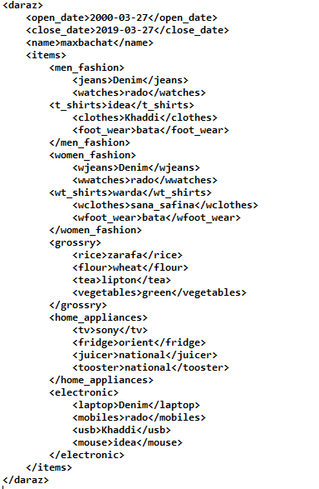

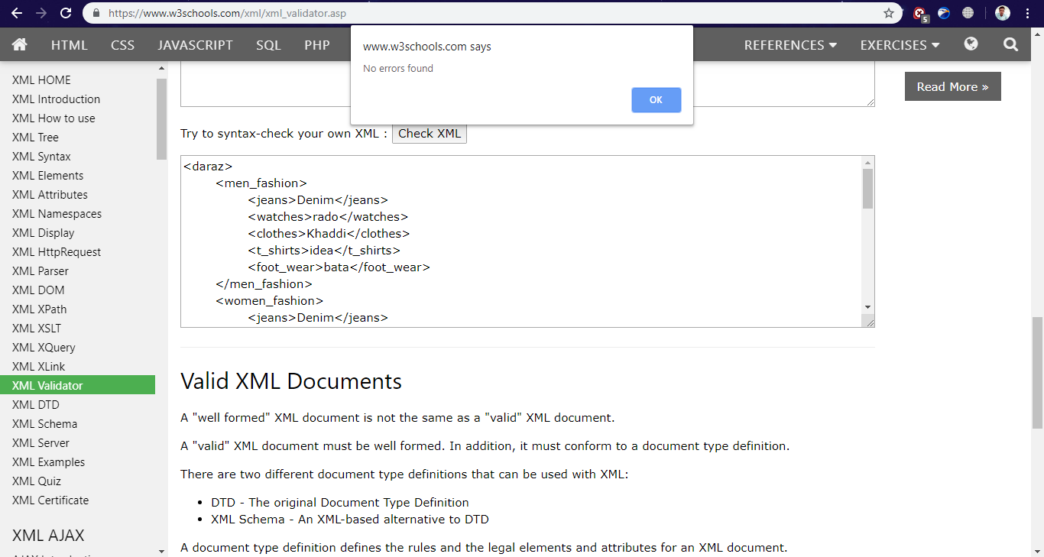

**Task 2: Create DTD for store XML Document. And validate on** [**http://www.w3schools.com/xml/xml_validator.asp**](http://www.w3schools.com/xml/xml_validator.asp)

**DTD:**

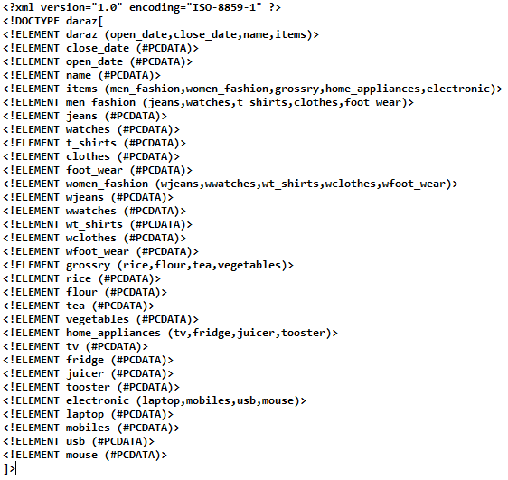

**Validation:**

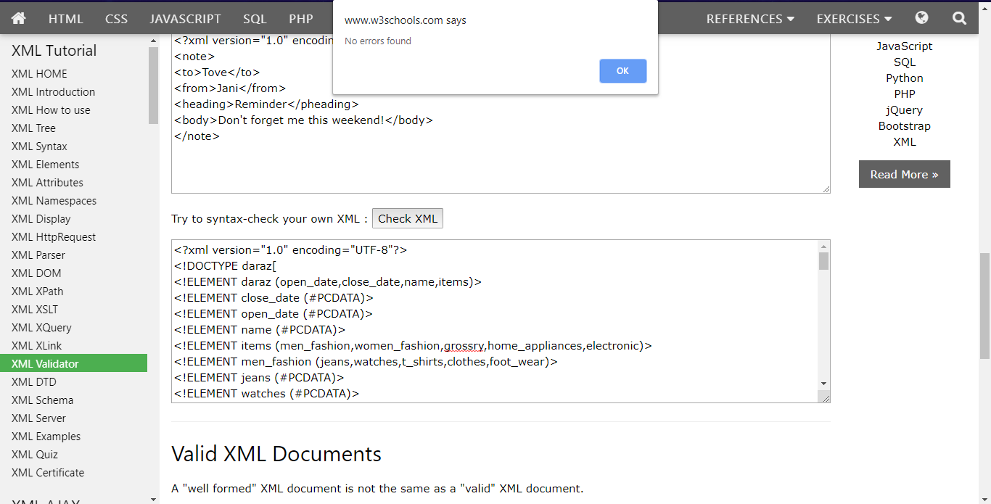

**Task 3: Write XML Schema for the following XML document and then validate the XML document along with its schema on the following website:**

[**http://www.utilities-online.info/xsdvalidation/#.UlFx2tKmhIg**](http://www.utilities-online.info/xsdvalidation/)

**<?xml version=“1.0” ?>**

**<movies>  
  <movie genre=“crime">  
    <title lang="en">The Godfather</title>  
    <year>1972</year>  
    <rating>9.2</rating>  
  </movie>  
  <movie genre=“horror">  
    <title lang="en">The conjuring</title>  
    <year>2013</year>  
    <rating>7.5</rating>  
  </movie>  
  <movie genre=“adventure">  
    <title lang="en">Everest</title>  
    <year>2015</year>  
    <rating>7.4</rating>  
  </movie>  
</movies>**

**XML Schema:**

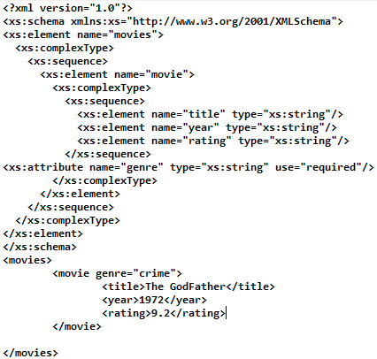

**Validation:**

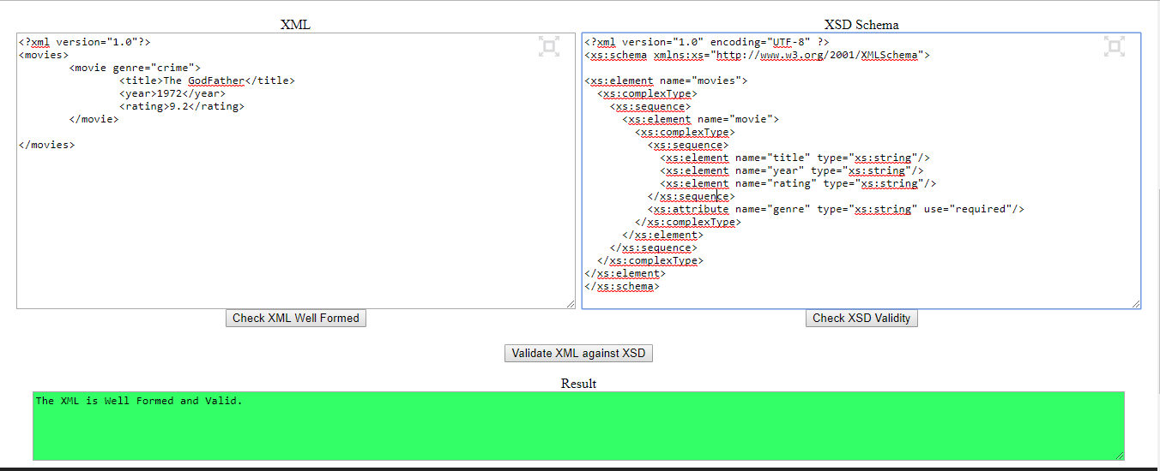

**Task 4: Write an XML instance for following schema and then parse that document in Java using either DOM or SAX API.**

**<?xml version=“1.0” ?>**

**<xs:schema xmlns:xs=“http://www.w3.org/2001/XMLSchema”>**

**<xs:element name="person“ type="persontype"/>**

**<xs:complexType name="persontype">  
<xs:sequence>  
 <xs:element name="firstname“ type="xs:string"/>  
<xs:element name="lastname" type="xs:string"/>  
<xs:element name=“date_of_birth” type=“date”/>**

**</xs:sequence>  
</xs:complexType>**

**<xs:complexType name=“date”>**

**<xs:sequence>**

**<xs:element name=“day” type=“xs:integer”/>**

**<xs:element name=“month” type=“xs:integer”/>**

**<xs:element name=“year” type=“xs:integer”/>**

**</xs:sequence>**

**</xs:complexType>**

**</xs:schema>**

**XML:**

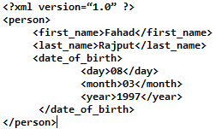

**Code:**

